Unit Two Colours
brown
white

red
orangege

Unit Two Colours
green
black

yellow
blue
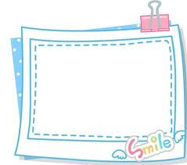

木作小学 三年级
Unit Two Colours

